## Custom Training:

Here I am using the same project that I have created for Image classification AutoML.

1. Project id: hw2p1-image

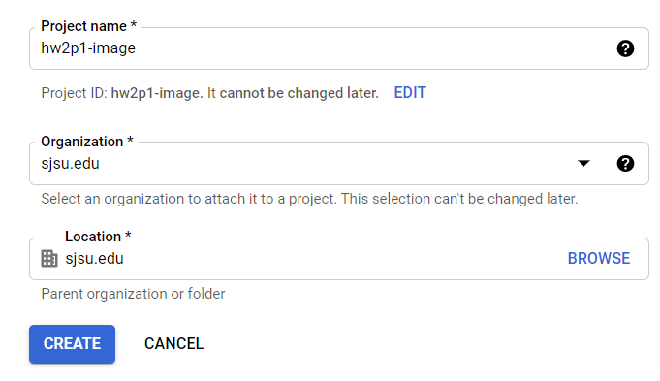

1. API is enabled

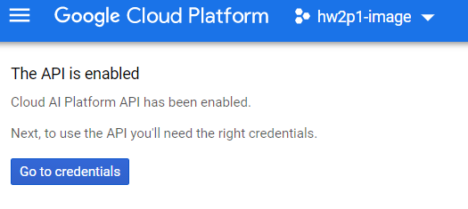

1. Authentication Setup

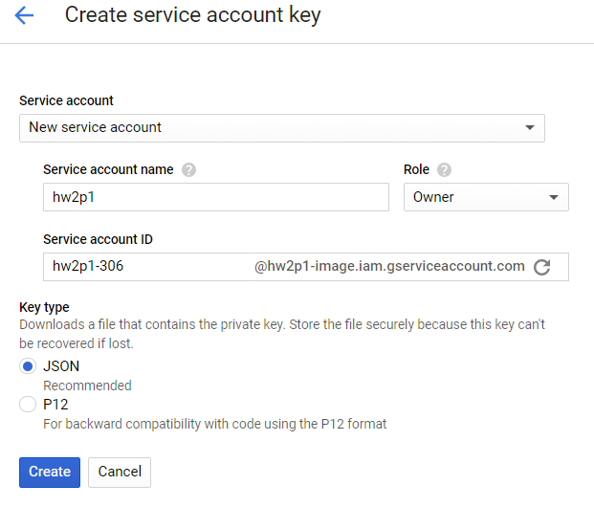

1. Set environment variable

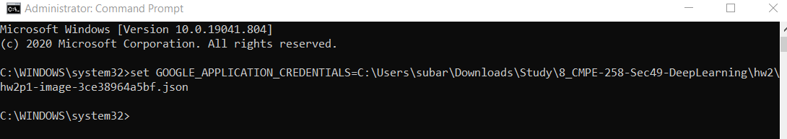

1. Cloud Console:

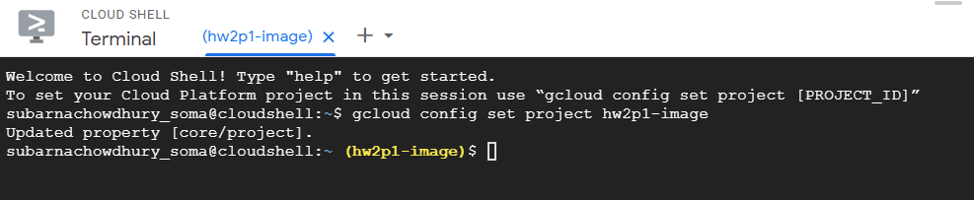

1. Created Google Cloud Storage Bucket

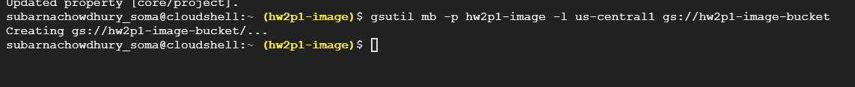

1. Downloaded sample code:

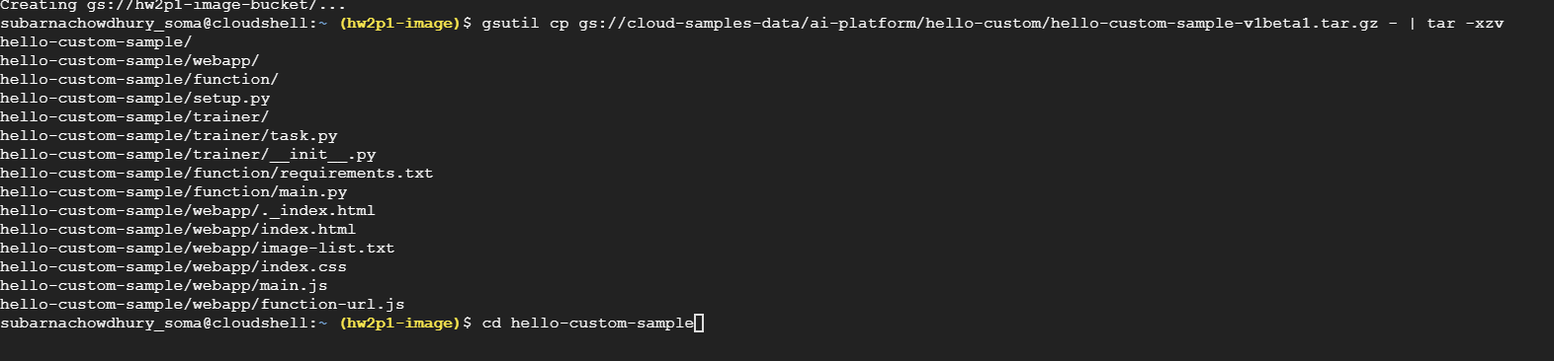

1. Explore the training code:

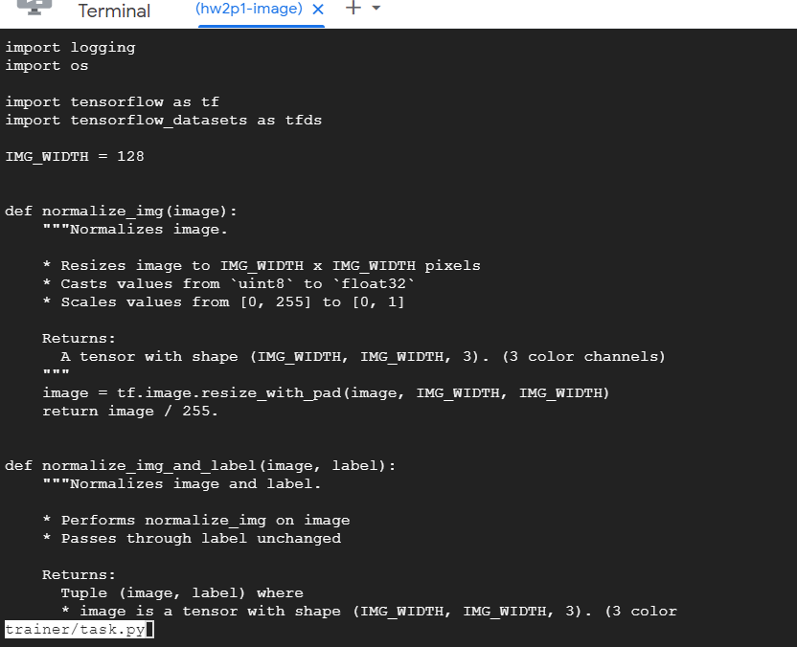

1. Setup.py

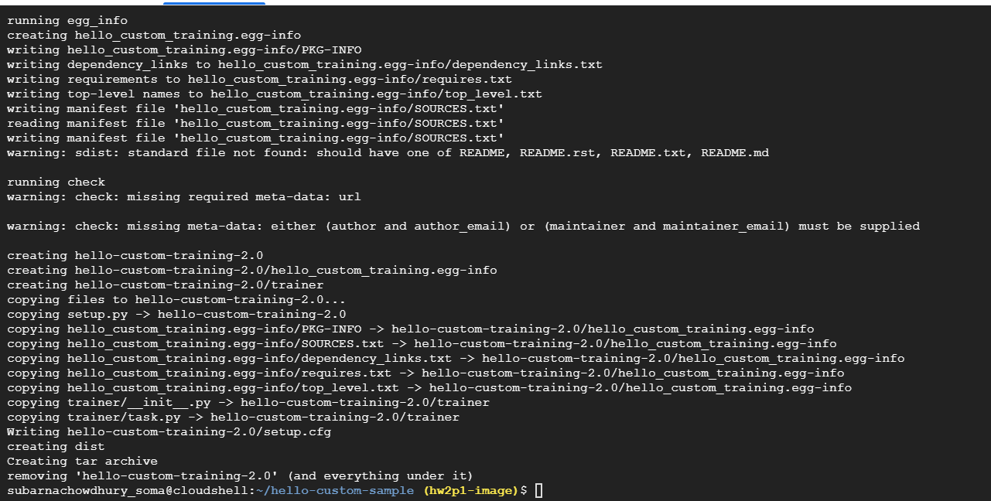

1. Running Hello Custom Training to Cloud Storage

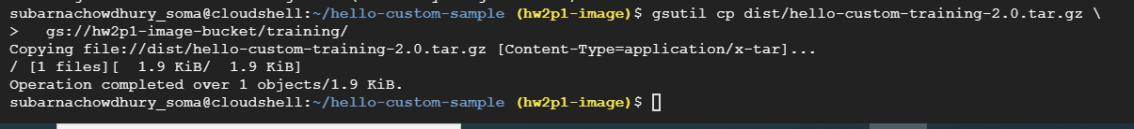

1. Created Custom Training Pipeline- Training method

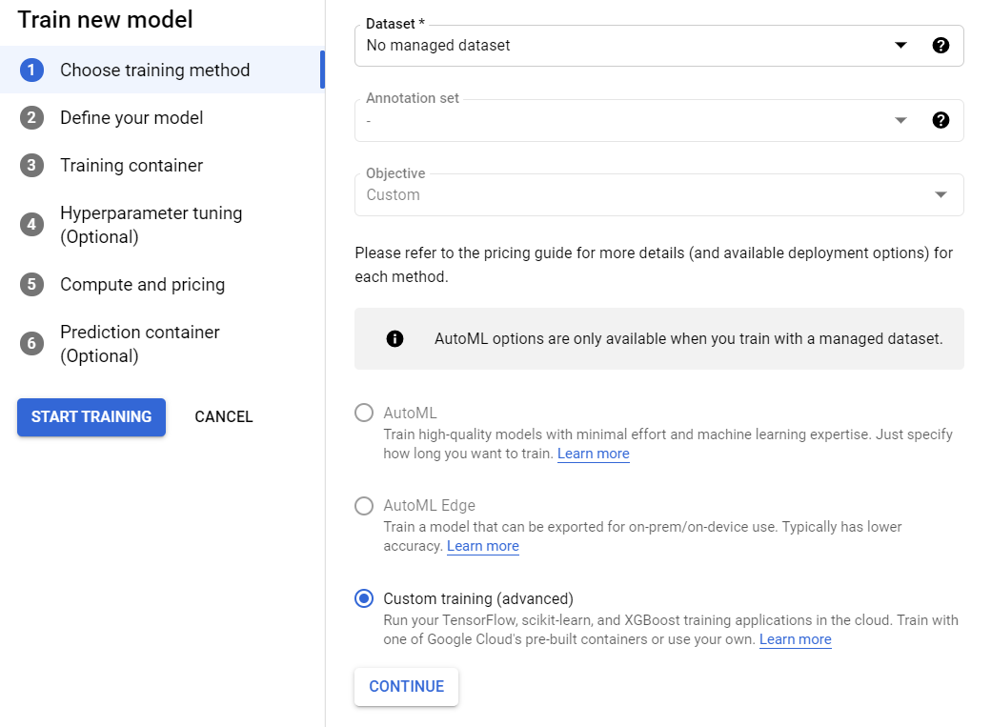

1. Defined Model Name:

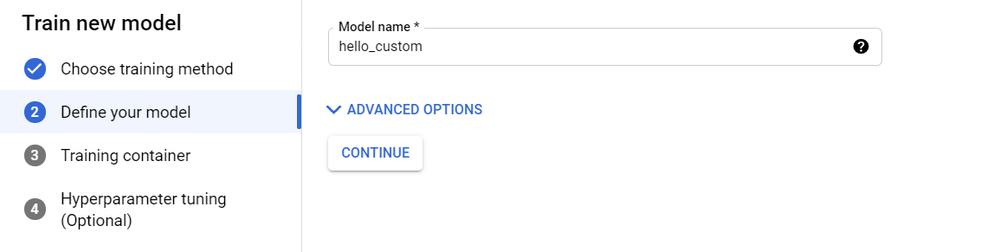

1. Training Container

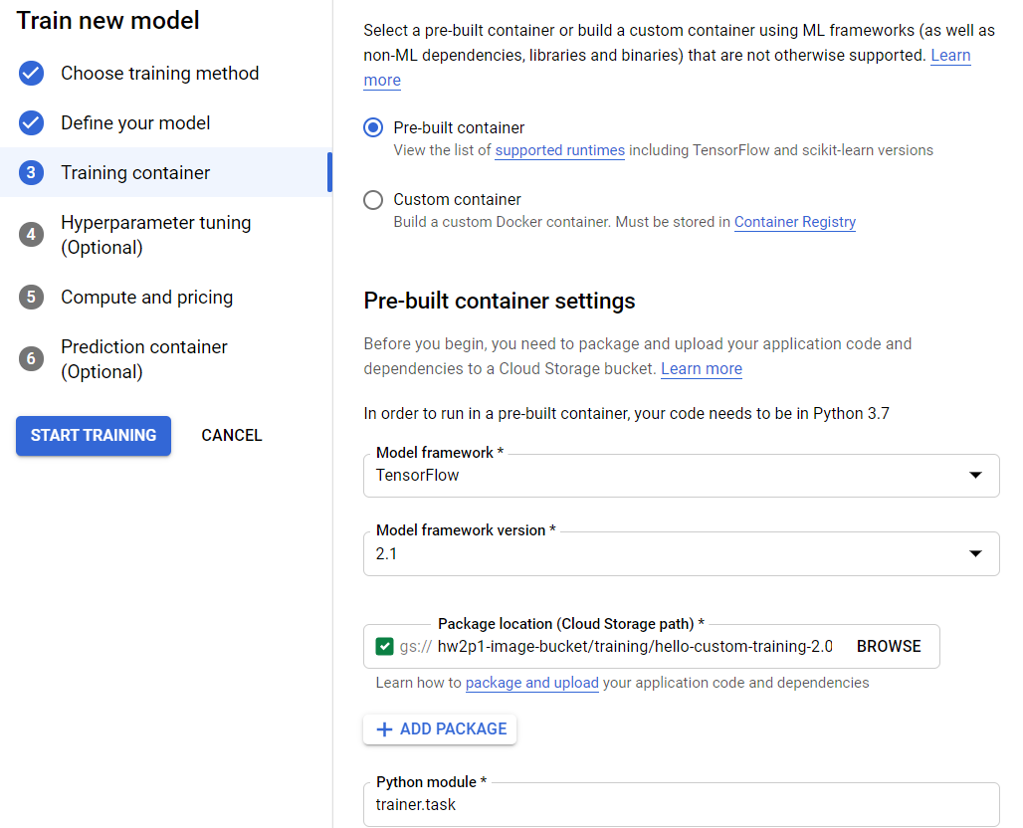

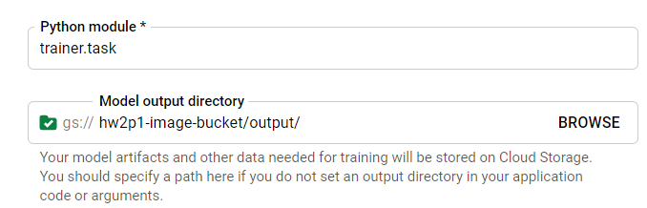

1. Hyperparam Tuning Cleared

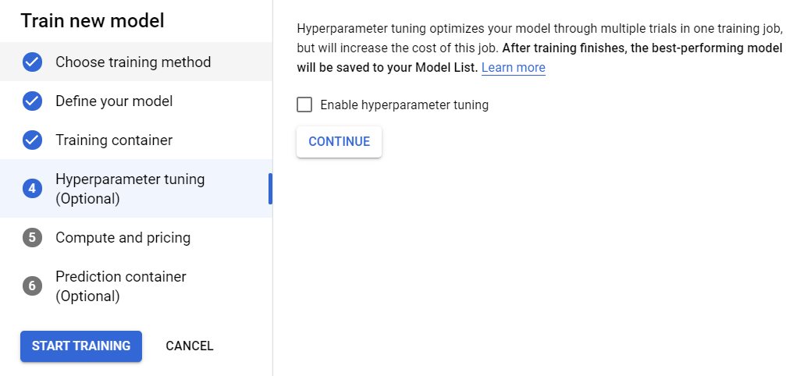

1. Compute and Pricing

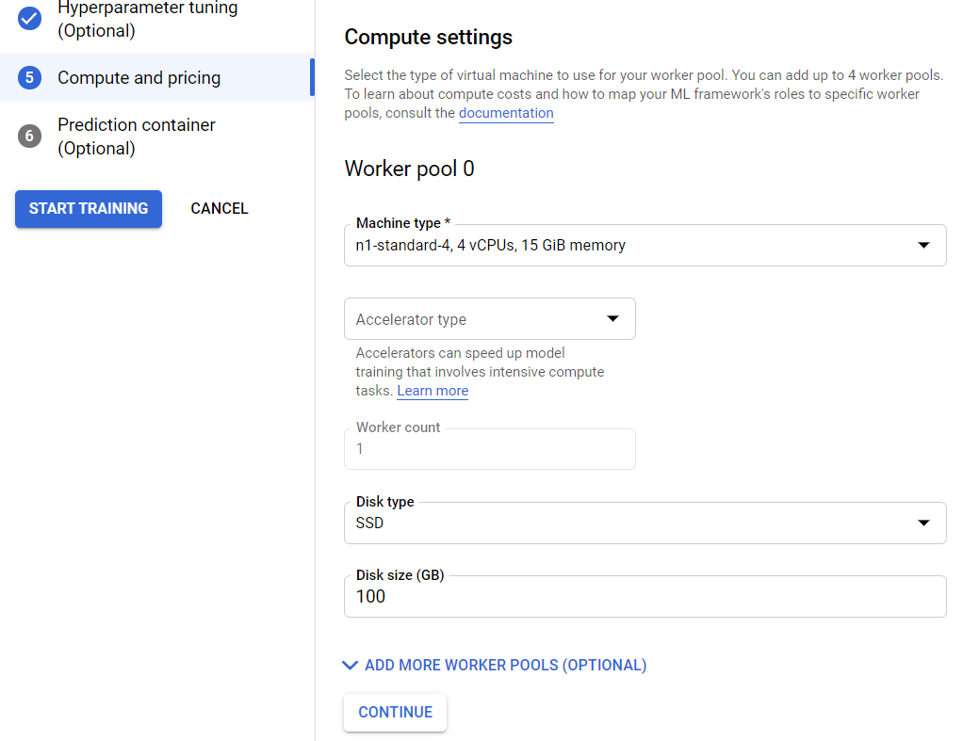

1. Prediction Container:

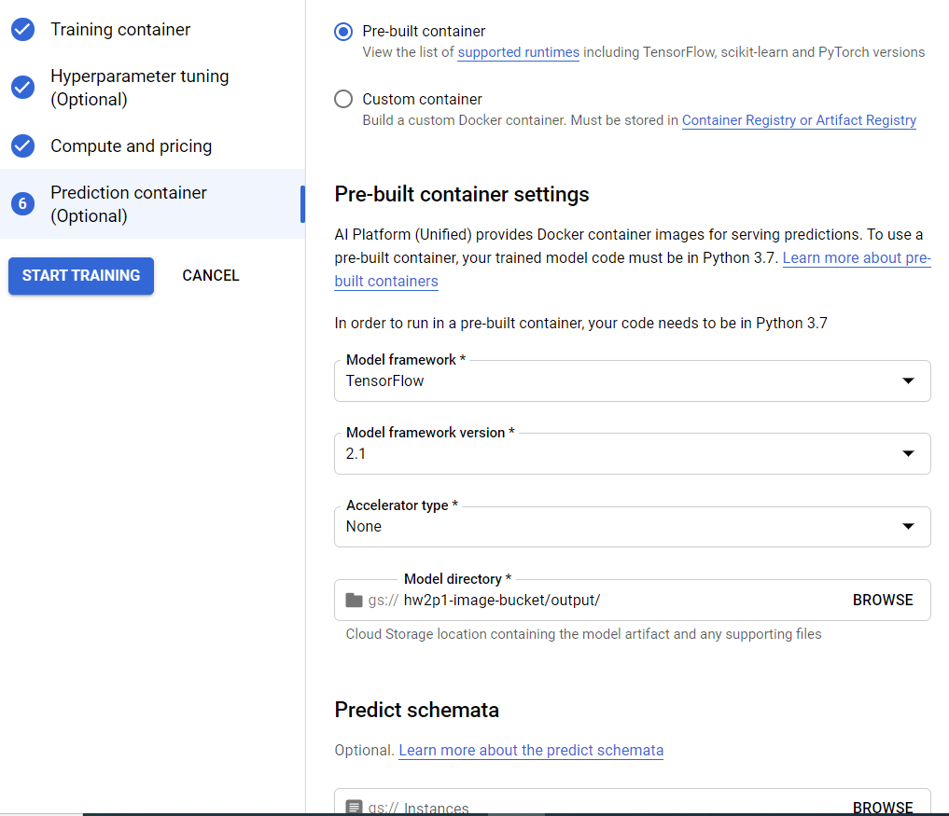

1. Training Started:

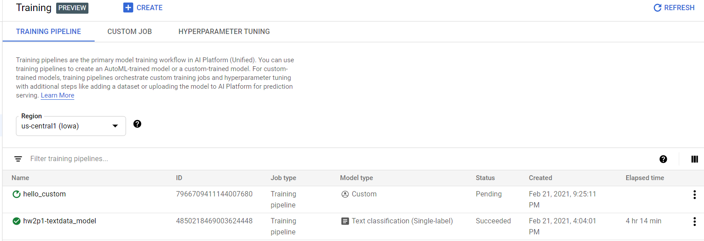

1. Created Custom Job

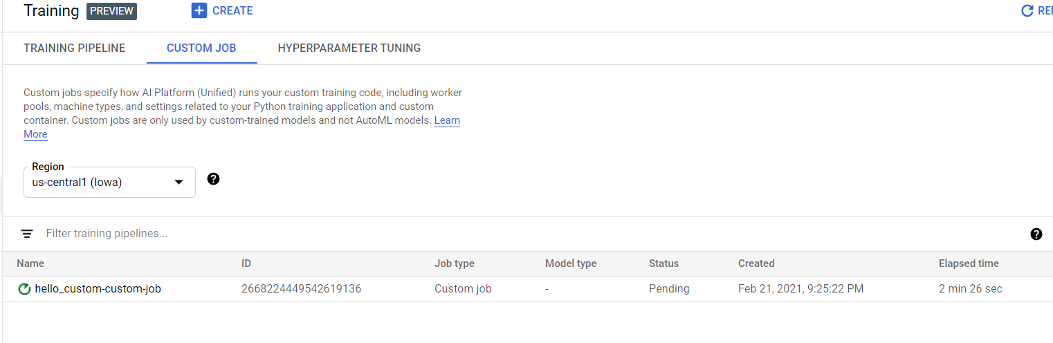

1. Custom Job Log

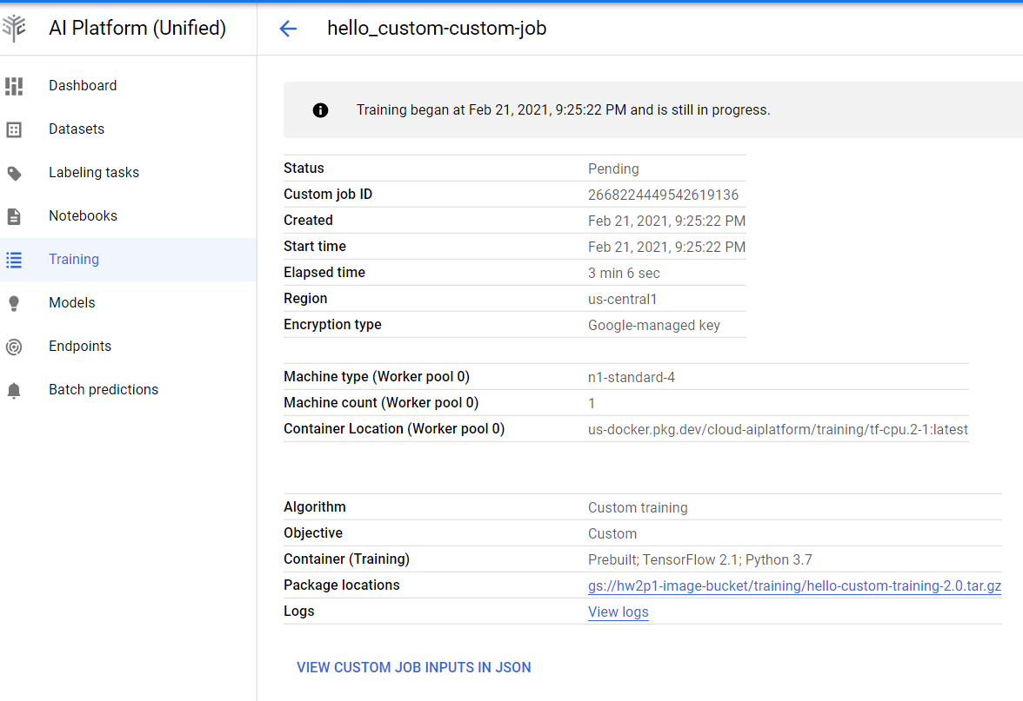

1. Model Created

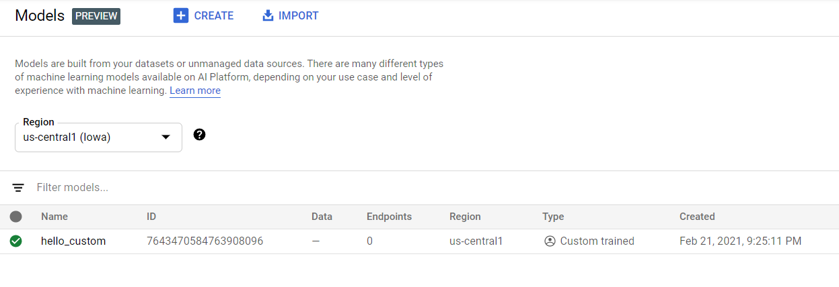

1. Created Deployment Endpoint

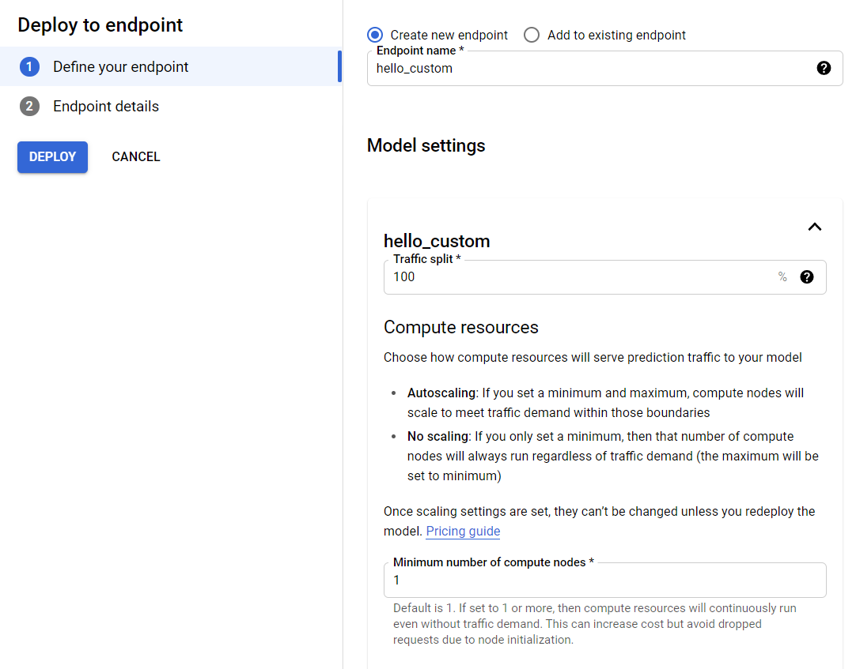

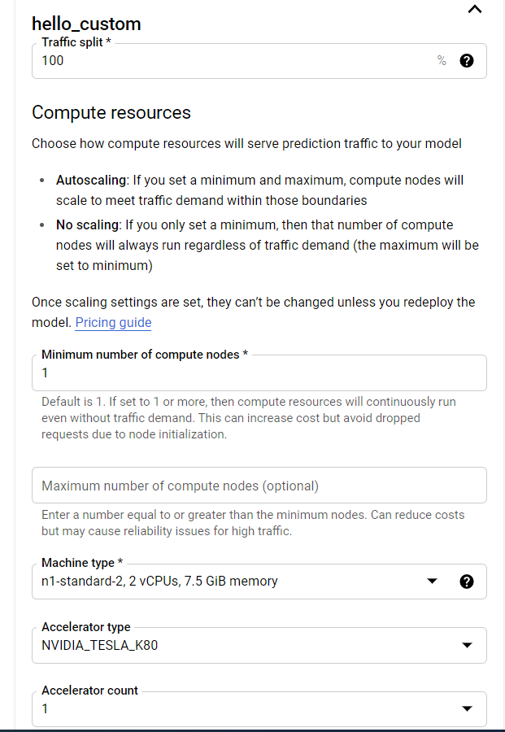

1. From Sample Request Pan:

ENDPOINT_ID="3689398072862834688"

PROJECT_ID="hw2p1-image"

INPUT_DATA_FILE="INPUT-JSON"



1. Deploying Cloud Function:

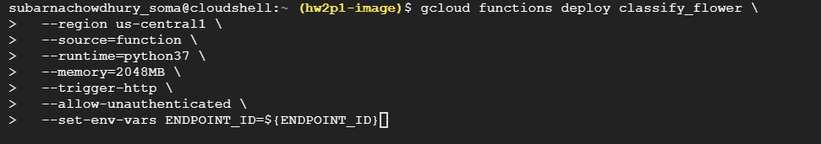

1. Web App deployment:









1. Prediction in web app: Navigate to this url: https://storage.googleapis.com/hw2p1-image-bucket/webapp/index.html

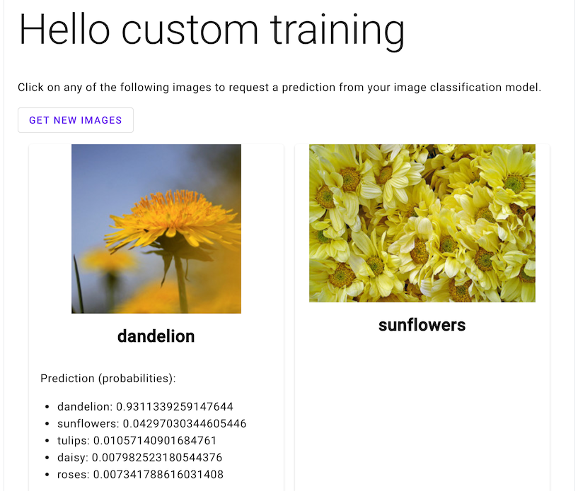

1. Deleted Bucket, function etc

